Reebok WOMEN FRANCHICE TRACK JACKET
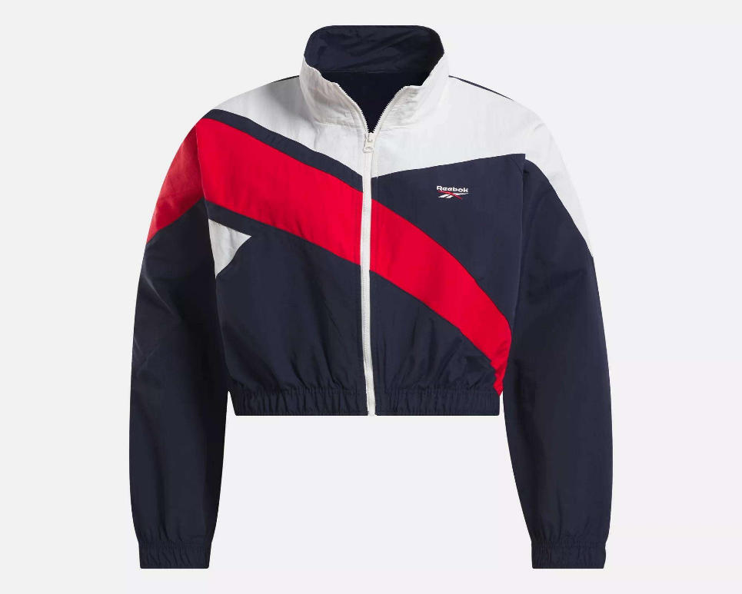
PRICE: Approximately Rs. 6,499

_{Introduction:}
The Reebok Women's Franchise Track Jacket is a versatile and stylish outerwear piece designed for both performance and everyday wear. Made for women who value comfort, fashion, and functionality, this jacket combines a modern fit with classic Reebok branding. Its lightweight construction allows easy layering over activewear or casual outfits, while the full-zip design provides customizable coverage. Perfect for workouts, jogging, or casual outings, the Franchise Track Jacket offers durability, breathability, and a sleek sporty look that complements any wardrobe.
Product Overview:
The Reebok Women's Franchise Track Jacket is designed to offer warmth and flexibility without restricting movement. Featuring a full-zip front, ribbed cuffs, and a high collar, it provides excellent coverage during workouts or outdoor activities.
About the Brand:
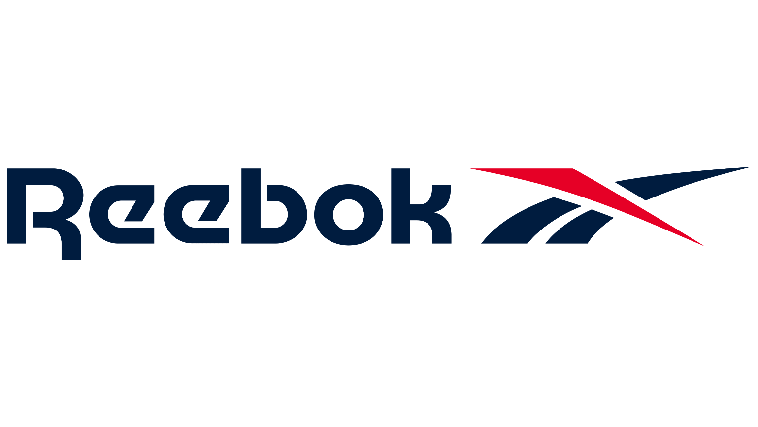
Reebok is a globally recognized sports and fitness brand known for producing reliable, high-performance athletic gear and accessories. With decades of experience in sports innovation, Reebok products are trusted by athletes and everyday users alike for quality, durability, and practical design.

Key Features:
- Lightweight and breathable fabric
- Full-zip front for adjustable coverage
- Ribbed cuffs and hem for secure fit
- High collar for added warmth
- Iconic Reebok logo branding
- Suitable for layering over active wear or casual wear

Design & Build Quality:
The Franchise Track Jacket features a slim, modern cut that flatters the female silhouette while allowing freedom of movement. Its carefully stitched seams and reinforced hems ensure durability, and the smooth fabric feels soft against the skin. The jacket’s full-zip front and high collar provide functional design without compromising style.
Storage & Capacity:
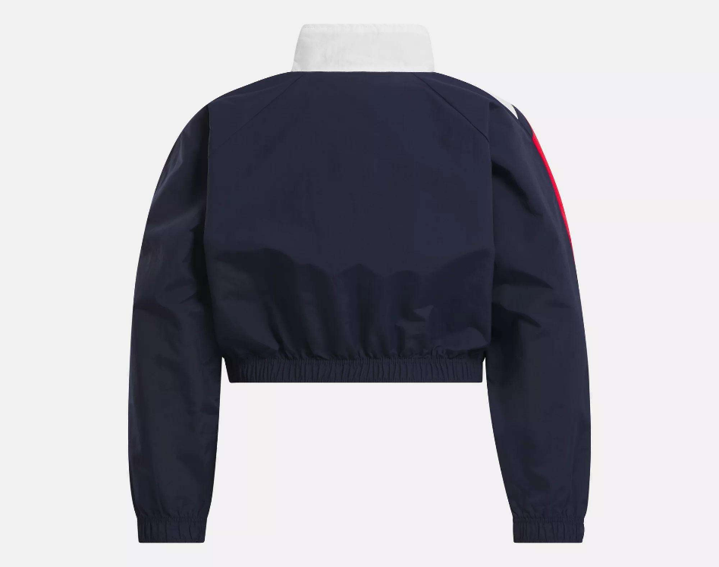
The Reebok Women's Franchise Track Jacket is designed with practical storage in mind, featuring two front pockets that comfortably hold small essentials such as keys, cards, or a phone. Its lightweight and flexible construction making it convenient for gym sessions, travel, or everyday wear.

Material & Durability:
Made from a premium blend of polyester and cotton, the jacket is durable, lightweight, and breathable. It is resistant to wear and maintains its shape after repeated use and washing, ensuring long-lasting performance.
Ideal For:
- Women athletes and fitness enthusiasts
- Casual wear or athleisure outfits
- Outdoor activities like jogging, walking, or warm-ups
- Layering for gym, travel, or everyday use
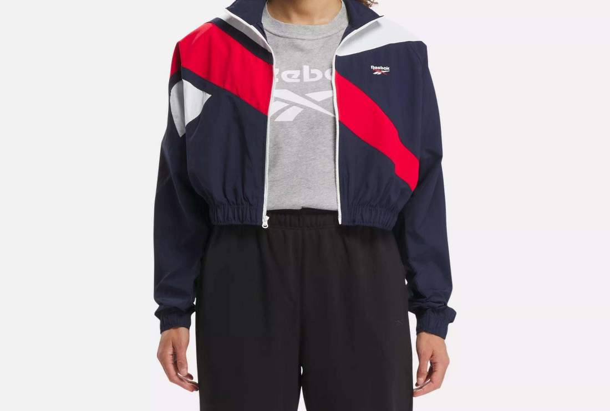

Care Instructions:
- Machine wash cold with similar colors
- Do not bleach or iron directly on logos
- Tumble dry low or hang to dry
Product Specifications:
- Brand: Reebok
- Product Type: Women’s Track Jacket
- Material: Polyester + Cotton blend
- Closure: Full-zip front
- Fit Type: Slim / Modern
- Pockets: Two front pockets
- Sizes Available: XS–XL
- Colors Available: Multiple colorways

Product Summary:
The Reebok Women's Franchise Track Jacket combines style, comfort, and performance in one essential piece of outerwear. Perfect for workouts, casual outings, or layering over activewear, it provides long-lasting durability, a flattering fit, and the iconic Reebok sporty style.

